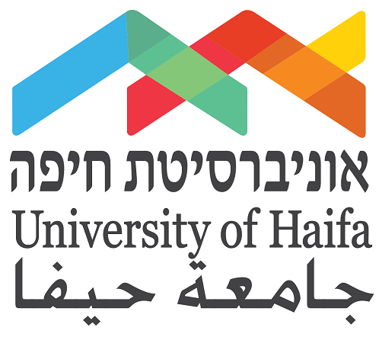

Fostering Computer Science Success
Among Minority Students

A Proposal for Support

The University of Haifa is Israel’s youngest and most pluralistic institution of higher education. From its inception, the University recognized its responsibilities to Israeli minorities, the majority of whom live in northern Israel, the region that the University serves. Our mission is to expand academic opportunities for all members of society, promote upward mobility and serve as an example of tolerance and coexistence in Israel and the entire region. To that end, the University is committed to cultivating success in the STEM disciplines, which offer minority students opportunities to succeed in Israel's increasingly technology-driven economy.
Israel has garnered international recognition for its booming high-tech industry. Despite the great demand for computer science professionals in Israel, the number of minority students pursuing and graduating from university-based computer sciences program has plenty of room for improvement.
Over the past few years, nearly 40% of incoming students enrolled in the Department of Computer Science at the University of Haifa have dropped out from the BSc degree program. To help address this challenge, the University of Haifa launched a computer science retention initiative several years ago, designed to provide talented minority students with extra academic support to significantly increase their success in completing their computer science degree. The initiative offered an intensive six-week summer program and a semester-long preparatory program. With more than 60% of the Department's students coming from minority communities, and a majority from economically disadvantaged homes, the initiative was an important statement demonstrating the University’s commitment to diversity and pluralism and making academic success widely accessible to all young people in northern Israel.
A recent assessment of the Program determined that the program is effective in helping improve student attrition rates. However many graduating students, in particular minority students, have a good theoretic basis but would benefit from more practical courses in applied computer science. Supplementing the students’ studies with such courses would provide them with the critical academic skills necessary to secure employment in Israel's highly competitive high-tech job market.
The Need. An undergraduate degree in computer science is considered among the most difficult programs offered at the University. More than 300 students apply each year to the Department of Computer Science, with only 100 being accepted. Although all of these students meet the stringent admission criteria, nearly 40% drop out.
High drop-out rates are a known challenge that many departments of computer science in Israel and worldwide are facing. The Department of Computer Science at the University of Haifa has to combat an even greater challenge owing to the unique makeup of its student body, and in particular its high rate of minority students. Students from minority communities face unique challenges to successfully integrate into the university learning environment. Although many students excelled in high school, they find the transition to university environment difficult. Having studied in Arabic in high school, they lack proficiency in Hebrew; they are on average three to four years younger than their freshmen peers because they do not serve in the Israeli military; they are often the first generation in their family to attend an institute of higher education and they are under financial pressure to finance their studies.
The Department of Computer Science
Our Students. The Department of Computer Science is characterized by a unique student population. Approximately half of our students are minorities, and this percentage has grown consistently since 2009. According to the National Institute for Testing and Evaluation, over the last decade, 20% of our students took their Psychometric Test (entrance exams) in Arabic, compared to 13.5%, 6.8%, and 2% at other universities. The Department is especially proud that one-third of its students are women.
Our Curriculum. Computer science is a very demanding course of study. It requires a strong background in mathematics and includes many hours of homework. Students attend an average of 25 weekly hours of classes, which require an additional 25 hours of time for mandatory homework assignments and studying for exams. Many of our students come from lower socioeconomic backgrounds and take jobs to support themselves during the school year, while trying to maintain their demanding course load.
Language Enrichment. Many Arab students arrive at the University with weak study and time management skills, and some with organizational difficulties. For many of these students, Hebrew is not their mother tongue, and they lack language proficiency in Hebrew and English.
Fostering Success in Computer Science
The proposed program will bolster the computer science curriculum by introducing a series of elective courses specifically tailored to improve the student’s applied computer science skills and improve their chances of gaining attractive employment in Israel's high-tech job market. Currently, the Department has 19 faculty members, and offers an undergraduate program that provides a very strong background in theoretical computer science. While the curriculum does offer practical courses in the areas of computer vision, bio-informatics, and machine learning, additional applied courses will further enhance their qualifications and give them a competitive advantage in their job search.
The following are examples of elective courses that will be added to the third-year computer science curriculum:
Software Engineering: Techniques for designing, building, and maintaining large, reusable systems. Advanced programming techniques using Java and Javascript. Software testing, relational databases, concurrency techniques such as threads, and software engineering tools like GIT, profilers, and debuggers.
Database Management Systems: Introduction to database structure, organization, languages and implementation. The relational model. Query languages, query processing and optimization, file structures, concurrency control and recovery algorithms. Distributed and dynamic databases.
Computer Science Meets Finance (FinTech): Bitcoin, Blockchain, and all that Jazz: Electronic and algo-trading, risk management, blockchain and cryptocurrencies, P2P lending, RegTech, InsurTech, data-driven credit risk analysis.

Program Impact
The courses will be added to the third-year curriculum and will be attended by a cohort of 100 students. The program's success will be measured by the number of students who receive attractive and competitive employment offers. Many minority graduates face challenges in launching their careers. They are younger than the average applicant and have less life experience than their peers. The additional courses will enhance their professional qualifications and employability.

The impact has the potential to be far reaching – it not only empowers the students, but also serves to promote Israel's economic and national interests. "Promoting success among minority computer science students can make a real change to the socio-economic map in Israel," notes Professor Daniel Keren, Head of the Department of Computer Science.
Academic Leadership

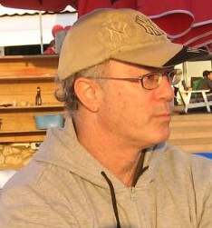
Professor Daniel Keren is the Head of the Department of Computer Science. He earned his PhD in Computer Science from the Hebrew University, and completed his post-doctoral fellowship at Brown University. Prof. Keren has published more than 100 papers in conferences and journals, and won many research grants, including seven Israeli Science Academy grants and four European Union consortium grants. He has served as a consultant to high-tech companies, including Hewlett Packard and Microsoft.

Request for Support
Expanding the pathways to computer-oriented careers will be key to affecting long-term social, educational and economic change within the minority community and building a brighter future for all of Israel. At this exciting time in the development of Israel’s scientific and high-tech efforts, the University of Haifa invites you to partner with us to support this important academic initiative.

- A gift of $50,000 will enable the University of Haifa to offer three additional courses to promote academic success among minority students in the field of computer science.
About the University of Haifa
The University of Haifa is embarking upon a new era that will transform the University into a magnet for the ‘best and brightest’ students and researchers and a fertile breeding ground for knowledge and innovation. Our mission is to expand academic opportunities for all members of society, promote upward mobility and serve as an example of tolerance and coexistence in Israel and the entire region.
Our campus is academic home to 18,000 students and faculty members from different ethnic, religious and socioeconomic backgrounds. Jews, Arabs, Druze, new immigrants, international students, IDF officers and security personnel come together to study, research, socialize, and prepare themselves for the challenges of a rapidly changing world. Our diversity differentiates us from other Israeli universities. It is a source of strength and gives us purpose.
The University’s 1,200 research and teaching staff serve seven faculties, 54 departments, eight schools and 69 research centers and institutes. The University has gained an international reputation in a variety of fields, including marine sciences, cancer and brain research, educational technology and security studies. We are the proud academic host of the IDF National Security College where senior personnel from the military and other branches of the security forces and intelligence community study for graduate degrees.
The University has forged strategic partnerships with outstanding institutions across the globe that enhances the quality of our research and provides our students with transformative experiences.
The University’s new five-year strategic plan is set to transform the University of Haifa into a multi-campus academic institution - a “Multiversity”. The Multiversity model will encompass academic entry points or portals across Haifa, the Galilee region and as far as China, that will offer world-class education in a broad range of academic and research fields. As the first academic institution in Israel to operate in such a format, the University of Haifa will consolidate its status as a leading multidisciplinary research institution and will serve as a catalyst for economic development and for strengthening Israel in general, and the North in particular.



